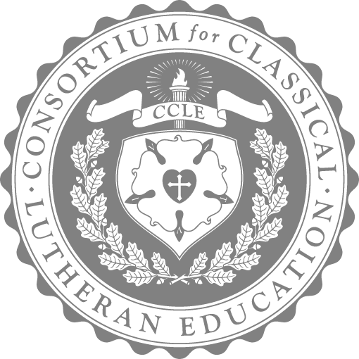

CCLE 2025 RECITATION CONTEST

Open to students ages 3 to 18 years old who attend a CCLE accredited school or whose parent has CCLE household membership

Deadline for submission: **May 15, 2025**

| ENGLISH RECITATION CONTEST[1] | | |
| --- | --- | --- |
| ENGLISH DIVISION | AGE IN YEARS[2]/AGE RANGE[3] | Predetermined  recitation  passage |
| PRE-SCHOOL | 3-4 |
| EARLY GRAMMAR | 5-7 |
| GRAMMAR | 8-12 |
| DIALECTIC | 13-14 |
| RHETORIC | 15-18 |
| LATIN RECITATION CONTEST1 | | |
| LATIN DIVISION | AGE IN YEARS/AGE RANGE2 | Predetermined  recitation  passage |
| GRAMMAR | 8-12 |
| DIALECTIC | 13-14 |
| RHETORIC | 15-18 |

ENGLISH DIVISION MEMORY FOCUS

Pre-School: The Ten Commandments

Early Grammar: Psalm 1 (ESV)

Grammar: Nicene Creed

Dialectic: Luke 1:26-56 (ESV) (spoken not sung)

Rhetoric: Acts 17:22-31 (ESV)

LATIN DIVISION MEMORY FOCUS

Grammar: *Credo*

Dialectic: *Te Deum*

Rhetoric: *Decem Praecepta*

CCLE 2025 RECITATION CONTEST

The CCLE 2025 Recitation Contest has two divisions: English and Latin. Students may compete in either English or Latin, but not both. Students have the option of competing in their own age division or a higher division, which must be indicated on the performance information page.

For the English and Latin Recitation Contests, the CCLE has identified specific selections for age categories. These are available in the 2025 Recitation Contest Selections documents.

Students memorize and recite specific pieces for recording. After the performance is recorded, the teacher or parent sends the file to contests@ccle.org to upload the performance. Receipt of uploaded videos will be acknowledged; do not delete video recordings until after June 30, 2025.

EVALUATION CRITERIA: SEE SCALES

* eye contact with audience
* recording captures contestant from waist up (focused on face)
* confident, non-hesitant recitation from memory
* clarity of voice, accuracy, enunciation, and pronunciation
* standing posture and appropriate movement to convey emphasis or emotion
* appropriate intonation and rhythm (Latin should be recited in meter)
* appropriate volume of voice in recording

CONSIDERATIONS/DIRECTIONS

1. The student must be the required age on the submission deadline.
2. When reciting, the student is declaring that he has memorized the passage and is neither reading nor benefitting from external prompting in any way.
3. When the recording begins, each student will introduce his name and age. The introduction should take no more than 10 seconds.

1. Only one recitation may be submitted per student. Students may compete in only one recitation division (English or Latin).

PROCESS

1. The school or classroom/homeschool teacher shares the 2025 Recitation Contest directions with students. If there are any questions about the directions, please contact contests@ccle.org.
2. Each performance must be listed on a performance information page (see page 5). This performance information page must be emailed to contests@ccle.org.
3. Each performance must be recorded separately and sent as a single file; not sent in a large, multiple entries file.
4. The classroom/homeschool teacher records and uploads the video(s). Please note the directions for uploading and submitting the recorded video(s). You will need (or may need to create) a gmail account to have access to Google Drive.
5. Record one student’s performance as an individual file. Multiple student entries should be submitted as separate files.
6. Name the file of the student performance in this order:

Contest, language, division, age, last name, first name, school name

*Recitation, English, Early Grammar, 7, Melanchthon, Phillip, St Matthew Lutheran*

*Recitation, Latin, Grammar, 9, Caesar, Julius, Coliseum Academy*

1. Create a new folder in Google Drive.
2. Drag performance file into Google folder.
3. Right-click your folder in Google Drive and select “Get sharable link.”

This is an example: <https://drive.google.com/open?id=1dSFcUIS8SNmr6l4UPw0n8IFe4RzBD6xo>

1. Please share the link with contests@ccle.org.
2. The Performance Information Page AND recitation recording(s) must be uploaded electronically by midnight of the contest deadline, May 15, 2025. Receipt of uploaded videos will be acknowledged to the email address listed on the submission page; please do not delete videos from storage until after June 30, 2025.

6. All submissions will be evaluated using the CCLE Recitation Scale.

7. Winners will be announced by CCLE social media and website (first name and last name initial), the conference program (full name), and any other CCLE print publications (full name). Contest entry assumes permission for the above.

PRIZES

PRE-SCHOOL, EARLY GRAMMAR, & GRAMMAR DIVISIONS:

GRAND PRIZE: $100 for the student, $50 for the teacher

RUNNER-UP: $50 for the student, $50 for the teacher

DIALECTIC & RHETORIC DIVISIONS:

GRAND PRIZE: $200 for the student, $50 for the teacher

RUNNER-UP: $100 for the student, $50 for the teacher

Performance Information Page

Submit to: contests@ccle.org

Teacher or School: Please print clearly the student and teacher/parent names (complete names: first and last). Then complete the video file name at the time of recording.

School name:/Homeschool family: _________________________________________________________

Grade: _______________ Teacher: ___________________

Teacher/Parent email address: _________________________________________________________

Mailing address:

_________________________________________________________

Please follow this naming procedure:

Contest, language, division, age, last name, first name, school name

*Recitation, English, Early Grammar, 7, Melanchthon, Phillip, Hope Lutheran, Seward, WI*

*Recitation, Latin, Grammar, 9, Caesar, Julius, Coliseum Academy, Rome, Italy*

| Video File Name |
| --- |
|  |
|  |
|  |
|  |
|  |
|  |
|  |

1. For greater challenge any student may compete in a category higher than his chronological age, but no student may compete in a category lower than his chronological age.
2. The student must be the required age on the submission deadline.
3. Students with professional written documentation of diagnosed special needs may enter contests at a level lower than chronological age, subject to prior approval by the CCLE. Contact the executive director at executive.director@ccle.org for this opportunity.