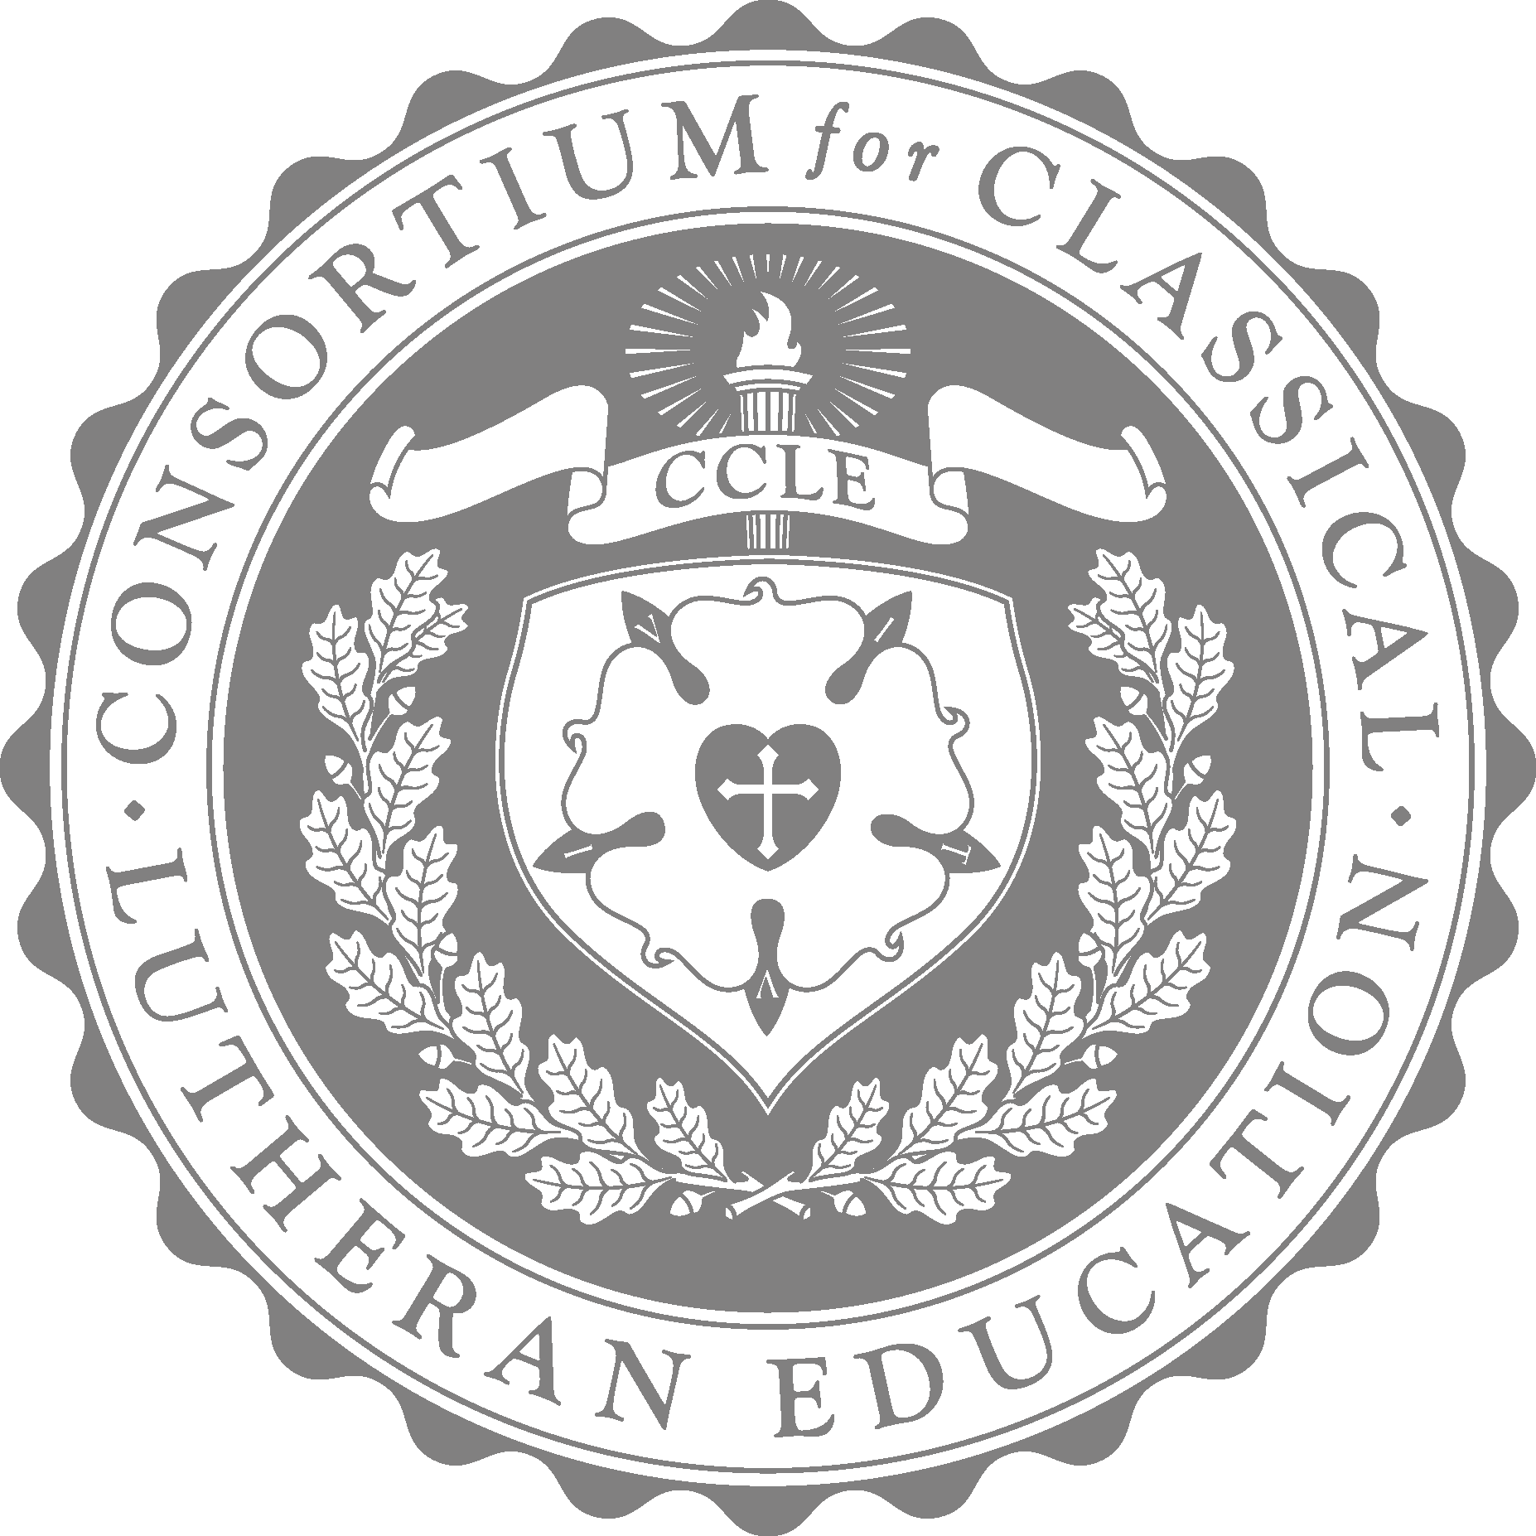

CCLE 2025 POETRY CONTEST

Open to students who attend a CCLE accredited school or whose parent has CCLE household membership

Deadline for submission: **April 15, 2025**

*Theme: Celebrate the festival!*

CCLE is pleased to announce poetry as its composition contest for 2025. Students will compose a poem of 12-48 lines that follows a definite meter. Poems will be evaluated on the following points:

* Doctrinal purity
* Choice of theme
* Development of theme
* Choice of poetic form and meter
* Adherence to the meter
* Alignment of natural stress of words with the meter
* Good grammar

| Divisions[1] | |
| --- | --- |
| A | 13-14 years old |
| B | 15-18 years old |

CONSIDERATIONS/DIRECTIONS

1. The teacher or parent may help to explain or clarify the prompt, directions, and evaluation scale, but it must be entirely the student’s work and thought. If the prompt is used as an in-class assignment, it must be solely the student’s work.

2. The entry must be word-processed. All text should be on one side of paper only—it must be readable when scanned. Formatting must be double-spaced, font size 12, Times New Roman, black only.

3. The school can submit one Composition entry only per student.

4. This entry must be an original, unpublished work. The CCLE reserves the right to publish all submissions with author attribution.

PROCESS

1. For schools: The school completes the submission page including a list of the entries by age group with students’ names and category (page 4). The student’s name, age, and school name should be only on the submission page; it should not be on the entry itself.

For homeschool families: Please complete the submission page including the student’s name and age category and the parent’s name as teacher (attached). The student’s name should only appear on the submission page; it should not be on the entry itself.

2. The school scans each submission as an electronic pdf. The entry must be clearly legible in the pdf to be evaluated. Please identify the electronic pdf submissions according to the following pattern:

*Title, last name of student, first name of student, age, school, town*

*The Lamb Has Come, Chemnitz, Martin, 13, Brandenburg Lutheran School, Brandenburg*

The classroom/homeschool teacher uploads the entries to a file on google drive and shares permission to view and edit with [contests@ccle.org](mailto:contest@ccle.org).

4. The school then emails the shareable link and submission form with students’ names to contests@ccle.org.

The submission page and the scanned entries must be submitted electronically and sent by midnight (Central Time) of the contest deadline, April 15, 2025. Submissions will be acknowledged upon receipt of scanned materials. Please do not delete the file from your storage until after June 1, 2025.

5. The judges will evaluate all entries using the CCLE scales.

6. Winners will be announced by CCLE social media and website (first name and last name initial), the conference program (full name), and any other CCLE print publications (full name). Contest entry assumes permission for the above.

PRIZES

Prizes consist of the following:

Grand Prize: $200 gift card for the student and $50 gift card for the teacher   
 Runner-Up: $100 gift card for the student and $50 gift card for the teacher

SUBMISSION PAGE

Submit to [contests@ccle.org](mailto:contests@ccle.org)

Teacher or School: Please type or print clearly all student names (complete names: first and last) and information.

School name/  
Home school name: _____________________________________________

Teacher:_____________________________________________________

School address:_________________________________________________

Email address:__________________________________________________

Mailing address:_________________________________________________

Please list the poetry entries following this pattern:

poem title, student’s last name, student’s first name, age, school, town

*The Lamb Has Come, Chemnitz, Martin, 13, Brandenburg Lutheran School, Brandenburg*

**This is the only connection between the scanned entries and student names.**

| Poetry PDF Files |
| --- |
|  |
|  |
|  |
|  |
|  |
|  |
|  |

1. For greater challenge any student may compete in a category higher than his chronological age, but no student may compete in a category lower than his chronological age.