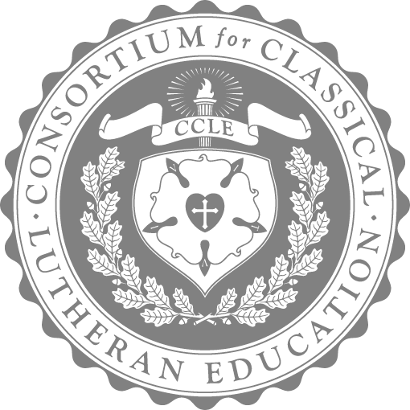

CCLE 2025 PENMANSHIP & CALLIGRAPHY CONTEST

Open to students ages 3 to 18 years old who attend a CCLE accredited school or whose parent has CCLE household membership

Deadline for submission: **March 15, 2025**

| Categories of penmanship & calligraphy |  | Ages[1] |
| --- | --- | --- |
| Manuscript (print) | Early Grammar | 4-5 |
| Manuscript (print) | Grammar | 6-8 |
| Cursive | 6-8 |
| Cursive | 9-12 |
| Cursive | Logic/Rhetoric | 13-15 |
| Calligraphy (black lettering only, black only) | 13-18 |
| Calligraphy (illuminated, color) | 13-18 |

Scripture Verse

*For Christ, our Passover lamb, has been sacrificed. Let us therefore celebrate the festival…with the unleavened bread of sincerity and truth (1 Cor. 5:7-8).*

MANUSCRIPT & CURSIVE EVALUATION CRITERIA: SEE SCALE

* legibility
* neatness
* shape/slant/connections
* spacing
* size

CALLIGRAPHY EVALUATION CRITERIA: SEE SCALE

* legibility of lettering style & neatness
* consistency of letter formations
* spacing & size
* aesthetic appearance
* creativity of illumination

CONSIDERATIONS/DIRECTIONS

1. Print/Manuscript contestants will use #2 pencil and write on lined paper. Cursive contestants will use black pen and write on lined letter-sized paper. Calligraphy Lettering contestants will use black color only and unlined letter-sized paper. Calligraphy Illumination contestants will use their choice of colors and unlined letter-sized paper.
2. Students will not trace or follow projections on the submission paper in any way. [Teachers may utilize projections on a chalkboard or whiteboard in penmanship instruction.] The submission must be entirely the student's handwriting on one side of paper only.
3. Students may only enter one penmanship contest (either manuscript, cursive, or calligraphy).
4. Entries will be disqualified for misspellings, errors, or failure to follow submission guidelines.
5. Students must be the designated age by the date of submission.

PROCESS

1. The classroom/homeschool teacher will explain the contest directions to the students. The student's first and last name and age should be in the upper right corner of the BACK side of the penmanship entry. The classroom/homeschool teacher completes the penmanship submission page by type of penmanship, student name, and age following the format below:

*Penmanship, print, age, last name, first name, school, town*

*Penmanship, cursive, age, last name, first name, school, town*

*Calligraphy, black lettering, last name, first name, school, town*

*Calligraphy, illuminated, last name, first name, school, town*

1. Mail submissions and submission page to: CCLE Contests, 6601 Clayton Road 1-W, Clayton, MO 63117. Submissions must be postmarked by the contest deadline, March 15, 2025. Please allow time for delivery before the deadline. Receipt will be acknowledged via the email address provided on the submission page. Submissions will not be returned.
2. Winners will be announced by CCLE social media and website (first name and last name initial), the conference program (full name), and any other CCLE print publications (full name). Contest entry assumes permission for the above.

PRIZES

Manuscript & cursive prizes consist of the following:

GRAND PRIZE: $100 for the student and $50 for the teacher

RUNNER-UP: $50 for the student and $50 for the teacher

Calligraphy prizes consist of the following:

GRAND PRIZE: $200 for the student and $50 for the teacher

RUNNER-UP: $100 for the student and $50 for the teacher

Penmanship & Calligraphy Submission Page

Mail to: CCLE Contests, 6601 Clayton Road 1-W, Clayton, MO 63117

Teacher or School: Please type or print clearly all names (complete names: first and last) and information.

School/Home school: _____________________________________________________________

Teacher/Parent: _____________________________________________________________

School address: _____________________________________________________________

Teacher/Parent email address: _____________________________________________________________

Mailing address: _____________________________________________________________

List the entries according to the following:

*Penmanship, print, age, last name, first name, school, town*

*Penmanship, cursive, age, last name, first name, school, town*

*Calligraphy, black lettering, last name, first name, school, town*

*Calligraphy, illuminated, last name, first name, school, town*

| Entry |
| --- |
|  |
|  |
|  |
|  |
|  |
|  |
|  |
|  |
|  |
|  |
|  |
|  |
|  |
|  |
|  |
|  |
|  |
|  |
|  |
|  |
|  |
|  |
|  |
|  |
|  |
|  |
|  |
|  |

1. For greater challenge any student may compete in a category higher than his chronological age. Students with *professional* written documentation of clinically diagnosed special needs may enter contests at a level lower than chronological age, *subject to prior approval by the CCLE*.  Contact the Executive Director at [executive.director@ccle.org](mailto:executive.director@ccle.org) for this opportunity.